## RESEARCH SYSTEMS EXERcise

1

Explain differences between JavaScript Expressions and Angular Expressions? ( 3 mins)

e..g. void operator is not allowed in Angular expression, coma is not allowed.

Javascript :

Do not support filters

AngularJS

Expression inside HTML tags

We can use filters

2

Explain difference between factory and service in AngularJS? (2 mins)

Factory:

create an object, can add additional properties

return this factory Object,

Service:

Service is a constructor function

A service is instantiated using the “new” keyword, which means your entire service and anything mapped to “this” is returned.

3

Please take the attached JSON file and write a nodeJs or Java service/server side function to read the data and sort it by Symbol, Transaction type and Transaction id. The output should be stored in a file. (45 mins – 1 hour)

Used PHP tp read JSON file

<?php

// Read JSON file

$json = file_get_contents('./fruits.json');

echo $json;

?>

4

Please read the output of the exercise 3 above and show it in a responsive grid (Table structure) like below? (45 mins – 1 hour)

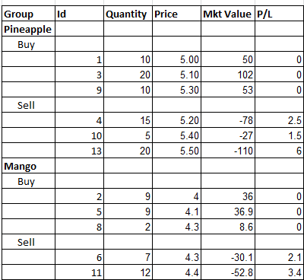

Output

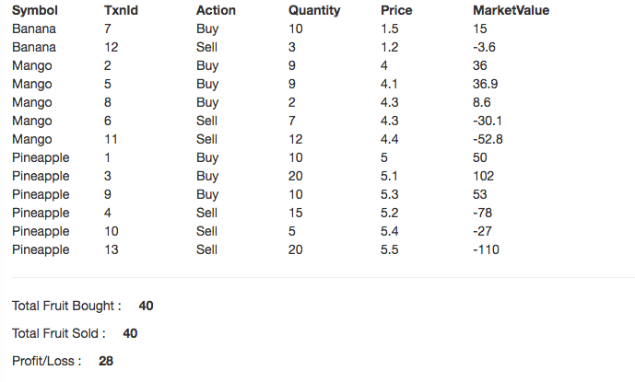

view

<div class="row" ng-controller="fruitController">

                        <hr>

                        <table class="fruitsTable" ng-init="getFruits()">

                            <tr>

                                <th>Symbol</th>

                                <th>TxnId</th>

                                <th>Action</th>

                                <th>Quantity</th>

                                <th>Price</th>

                                <th>MarketValue</th>

                            </tr>

                            <tr ng-repeat="fruit in fruits| orderBy: ['Symbol', 'Action']">

                                <td>{{fruit.Symbol}}</td>

                                <td>{{fruit.TxnId}}</td>

                                <td>{{fruit.Action}}</td>

                                <td>{{fruit.Quantity}}</td>

                                <td>{{fruit.Price}}</td>

                                <td>{{fruit.MarketValue}}</td>

                            </tr>

                        </table>

                        <hr>

                        <p>----- Pineapple ----- </p>

                        <p>Total Fruit Bought : <span class="result">{{totalFruitBought}}</span> </p>

                        <p>Total Fruit Sold : <span class="result">{{totalFruitSold}}</span> </p>

                        <p>Profit/Loss : <span class="result">{{profitLoss}}</span></p>

                        <hr>

                    </div>

fruitController.js

     $scope.totalFruitBought = 0;

     $scope.totalFruitSold = 0;

     $scope.totalBuyAmount = 0;

     $scope.totalSellAmount = 0;

     $scope.profitLoss = 0;

     $scope.getFruits = function () {

         console.log("LocalHost: fruitController---getFruits--------");

         dataFactory.getFruits()

            .then(function (response) {

                $scope.fruits = response.data.trades;

                calculateProfitLoss();

            }, function (error) {

                $scope.status = 'Unable to load fruit data: ' + error.message;

            });

    }

    function calculateProfitLoss(){

        var filteredFruits = [];

        angular.forEach($scope.fruits, function(fruit){

            if(fruit.Symbol == "Pineapple"){

                if(fruit.Action == "Buy"){

                    $scope.totalFruitBought += fruit.Quantity;

                    $scope.totalBuyAmount += fruit.Price;

                }else{

                    $scope.totalFruitSold += fruit.Quantity;

                    $scope.totalSellAmount += fruit.Price;

                }

            };

        // filteredFruits.push(angular.extend({}, fruit, {act:Action}))

        });

        console.log("totalFruitBought--- : " + $scope.totalFruitBought);

        console.log("totalFruitSold--- : " + $scope.totalFruitSold);

        $scope.profitLoss  = ($scope.totalSellAmount * $scope.totalFruitSold) - ($scope.totalBuyAmount * $scope.totalFruitBought);

        console.log("pineApplePL--- : " + $scope.profitLoss );

    }

dataFactory.js

     dataFactory.getFruits = function (member) {

        console.log("dataFactory::getFruits:-----------");

        return $http.post("/php/api/fruitsAPI.php");

    };

5

Use the output from the exercise 3 above and write a function to compute profit and loss for each sell transaction based on the First in First out for Pineapples.

P/L = Sell price * Sell Quantity – Buy price * Buy Quantity

Please show the output as a column on the grid/table displayed in exercise 4. (45 minutes to 1 hour).